**JOB APPLICATION TRACKING SYSTEM**

INTRODUCTION:

Tracking application means any software program whose primary purpose is to track or movement of an individual. An application tracking system is software for recruiters and employers to track candidates throughout the recruiting and hiring process. This software can come equipped with capabilities ranging from simple database functionality to a full size to filter manage and analyze candidates.

PURPOSE:

Organizations create job requisitions because they have identified a critical business need that current staffing levels do not address the job description must translate this business need into core responsibilities. But it must also capture the attention of the most qualified candidate. An ATS has a keyword-rich template for job descriptions that attract the right attention at the right time and in the places where top candidates are looking.

ACTIVITY AND SCREENSHOTS

CREATING A SALESFORCE DEVELOPER ORG:

Search [Developer.salesforce.com/signup](https://Developer.salesforce.com/signup)

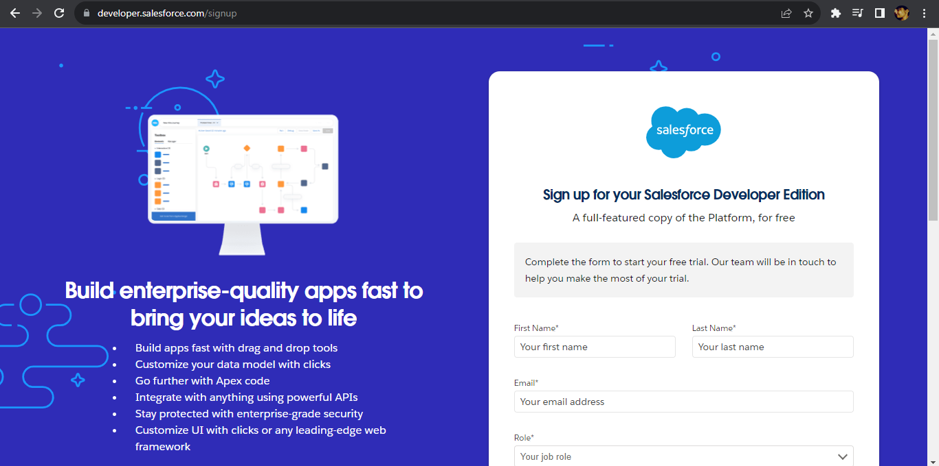

Entering the following details like First name, last name, Email, Role, Company, Country/Region, Postal code, and Username must be unique. Click sign me up, after a few min you will reserve a mail salesforce org and by using the verify account link you can create your new password and Click save.

Then Search [login.salesforce.com](https://login.salesforce.com/) , By using your username and password you can into Salesforce org.

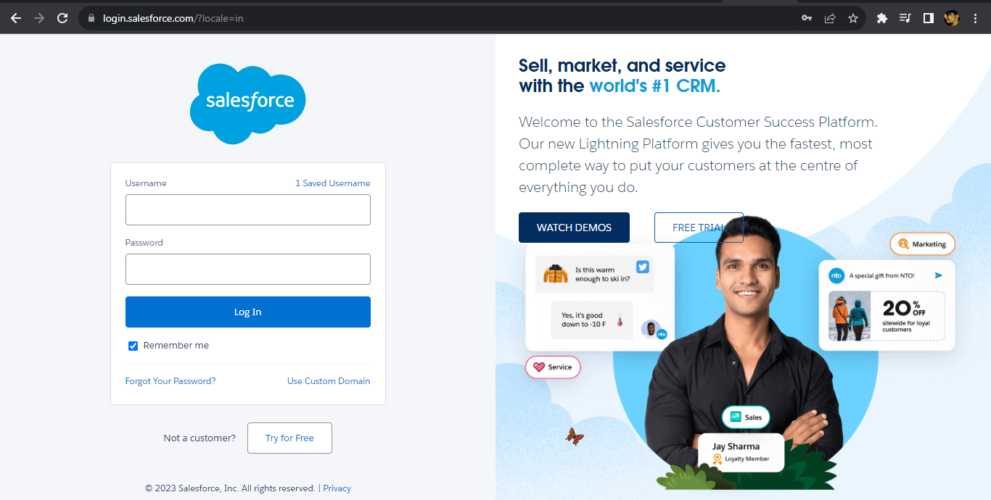

The home page will appear as below.

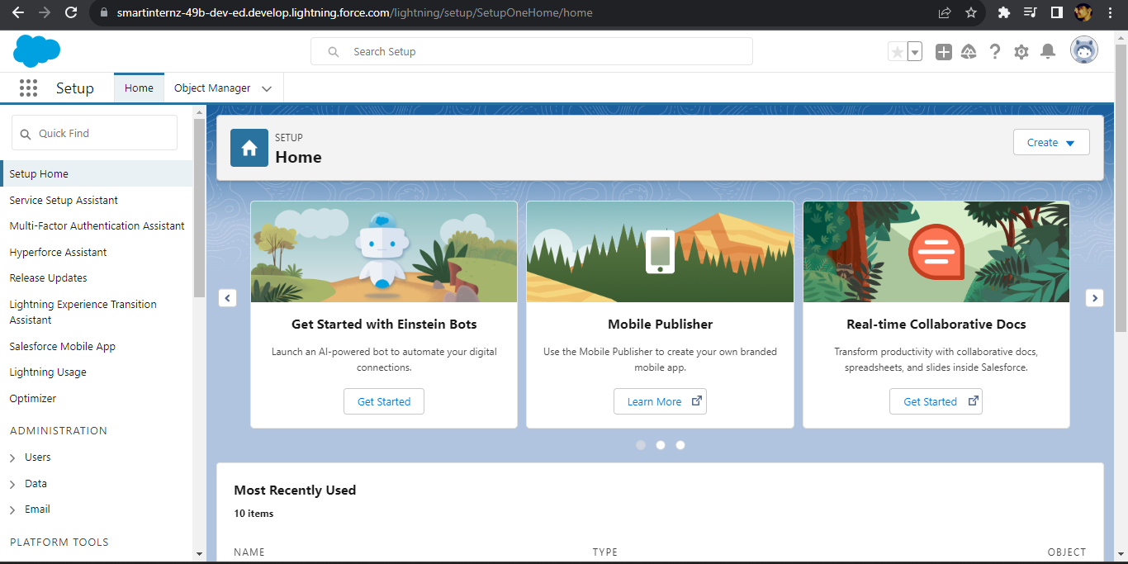

CREATE A CUSTOM OBJECT:

Custom objects are those objects that are created by users. They supply information that is unique and essential to their organization. They are the heart of any application and provide a structure for sharing data.

In This Application, We Use 4 Custom Objects  
1. Recruiter  
2. Jobs  
3. Candidate  
4. Job-Application

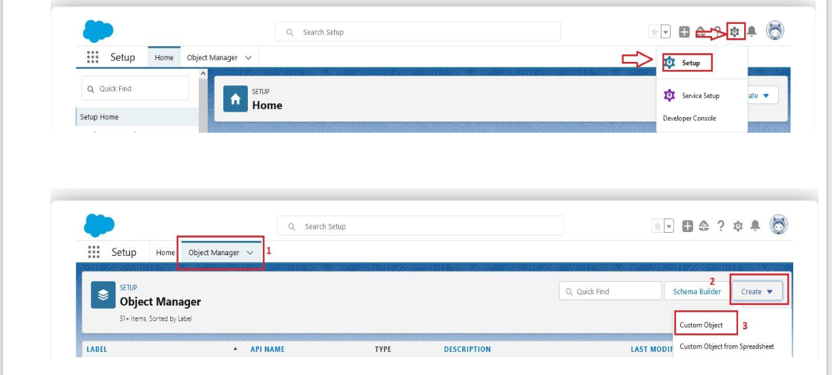

We can find the icon shown in the pictures above to create the custom object.

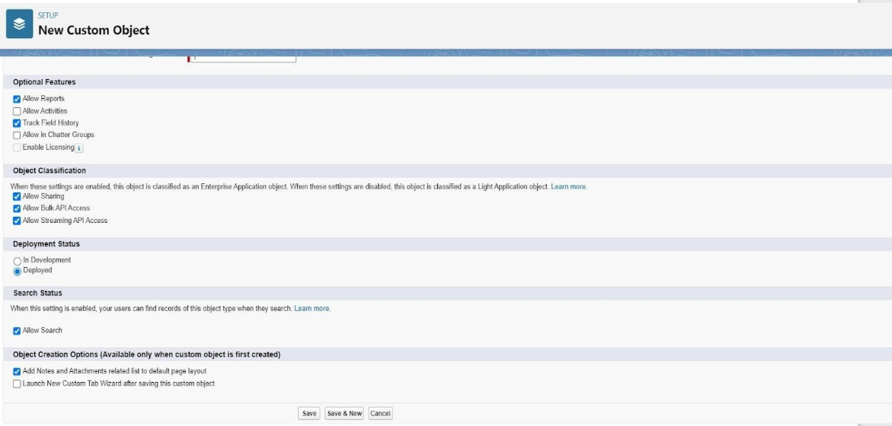

As shown in the above picture, create a custom object by select the given checkboxes.

CREATION OF TAB:

Tabs in Salesforce help users view the information at a glance. It displays the data of objects and other web content in the application. Custom object tabs display data related to custom objects. These tabs look and function just like standard tabs.

Now we are creating the tabs for custom objects – Recruiter, Jobs, Candidate, and Job Application.

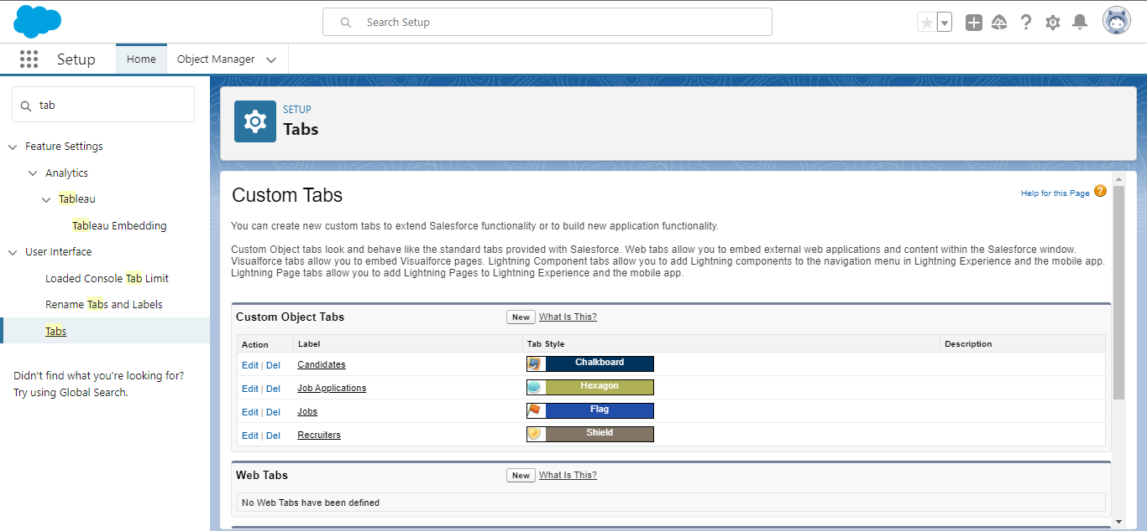

### CREATE THE JOB APPLICATION TRACKING APP:

### Apps in Salesforce are a group of tabs that help the application function by working together as a unit. It has a name, a logo, and a particular set of tabs.

### From Available Items, select Recruiters, Jobs, Candidates, Job Application Reports, and Dashboards and move them to Selected Items. Click Next and From Available Profiles, select System Administrator, and move it to Selected Profiles. Click Save & Finish. After that To verify your changes, click the App Launcher, type Job Application, and select the Job Application app.

### CREATION OF FIELDS FOR THE OBJECTS:

### Fields in Salesforce represent what the columns represent in relational databases. It can store data values that are required for a particular object in a record.

### 

### 

### 

### 

As shown in above pictures we created the fields and relationships for the objects which we created in the past.

CREATE A CUSTOM PROFILE:

A profile is a group/collection of settings and permissions that define what a user can do in Salesforce.

A profile controls “Object permissions, Field permissions, User permissions, Tab settings, App settings, Apex class access, Visualforce page access, Page layouts, Record Types, Login hours & Login IP ranges.

A profile can be assigned to many users, but user can be assigned a single profile at a time.

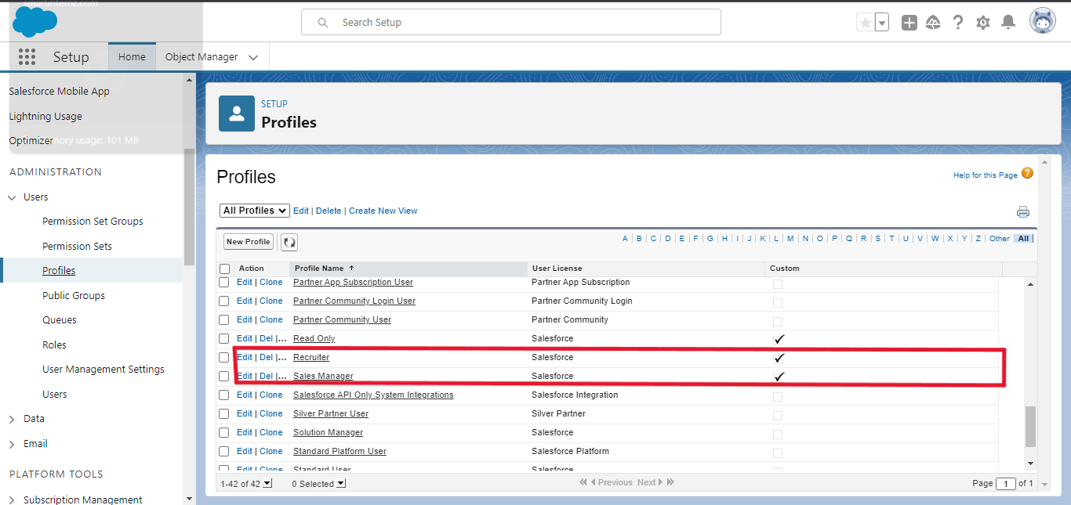

### CREATION OF ROLE:

### In Salesforce, roles are used to determine which users have access to certain data and functions within the system. They are also used to define the reporting hierarchy within an organization. Users with higher roles have greater access to data and more control over the system.

### 

### CREATE A USER:

### A user is anyone who logs in to Salesforce. Users are employees at your company, such as sales reps, managers, and IT specialists, who need access to the company's records. Every user in Salesforce has a user account. The user account identifies the user, and the user account settings determine what features and records the user can access.

### 

By filling the above details as shown in above picture, we created the users as shown in the below

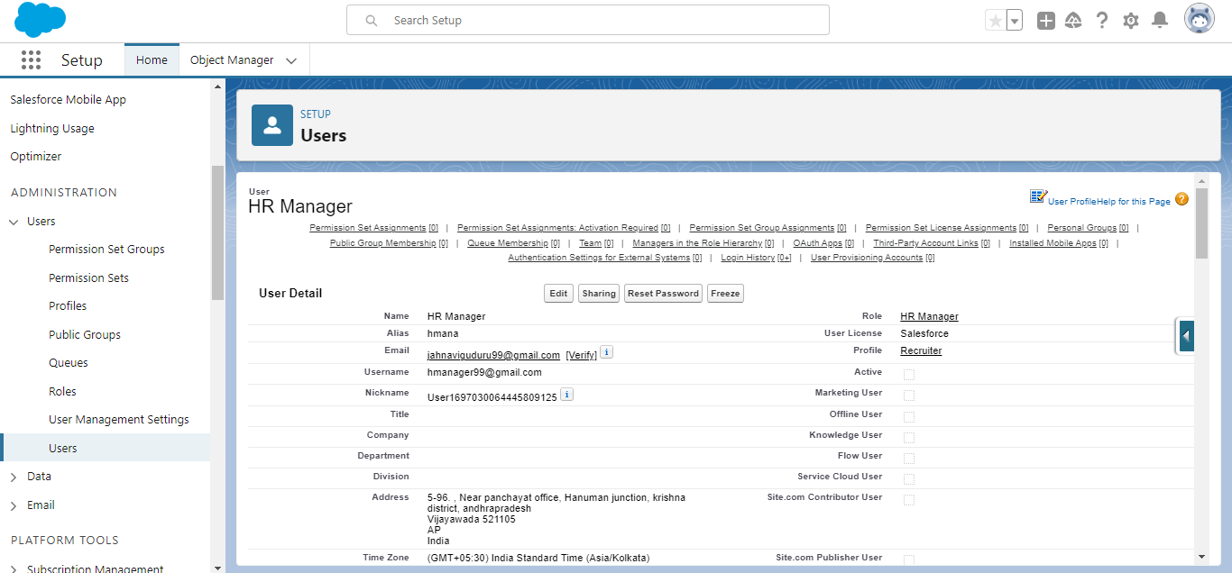

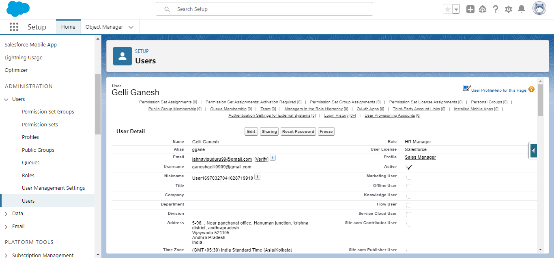

CREATE SHARING RULE:

Sharing rules help users to share records based on conditions. It is basically created for objects whose organization-wide defaults (OWD) are set to public read-only or private because sharing rules can only extend the access and not restrict it.

Types of sharing rules,

* Owner-based Sharing Rules
* Criteria-based Sharing Rules

Create a Sharing Rule to Share the records of Job Application to Hr Manager with the Access of Read/Write.

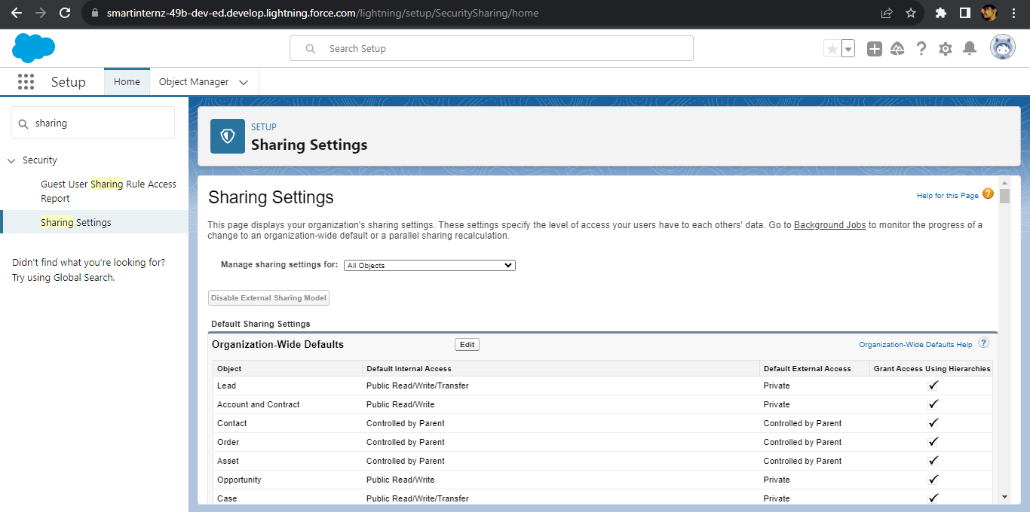

CREATE REPORT:

A report is a list of records that meet the criteria you define. It's displayed in rows and columns and can be filtered, grouped, or displayed in a graphical chart. Every report is stored in a folder. Folders can be public, hidden, or shared, and can be set to read-only or read/write.

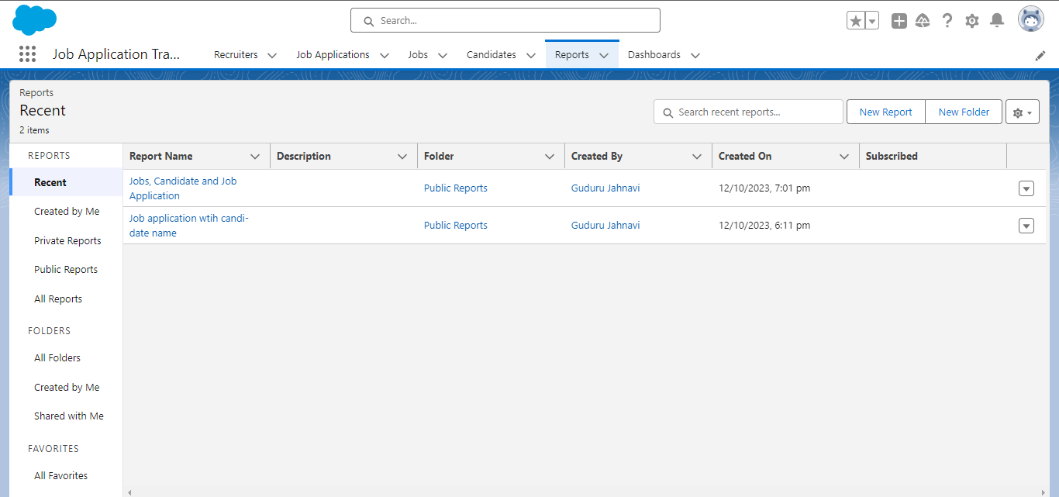

CREATE DASHBOARD:

Dashboards provide more insights than reports, combining the data from many reports and showing a summarized result. Looking at many reports at a time gives the flexibility of combining the results from them quickly. Also, summaries in dashboards help us decide on action plans quickly. The dashboards can contain charts, graphs, and Tabular data.

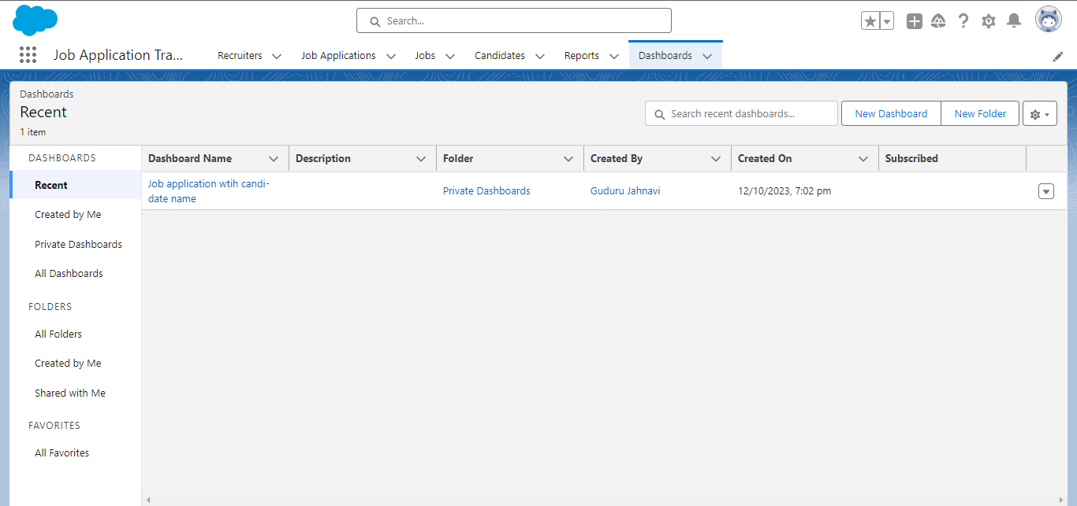

FINAL OUTCOME:

The below picture shows the final outcome of our project “JOB APPLICATION TRACKING SYSTEM”

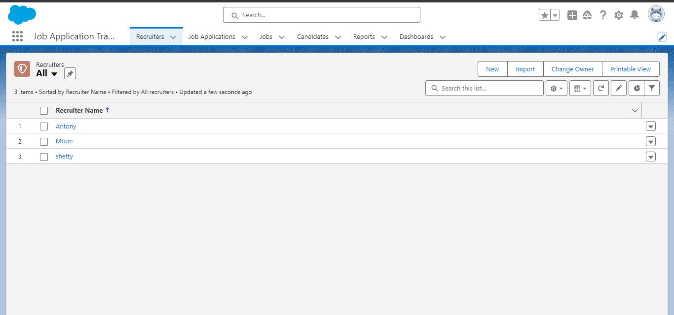

By clicking on App Launcher on left side of the screen. Search JOB APPLICATION TRACKING SYSTEM & click on it. And then Click on the Reports and Dashboard Tabs. Then Click on the job application with the candidate's name and there you can find the records that we are created.

Below picture shows the picture of the dashboards in job application tracking system,

